Description of the parameter space is given as a table. Each line of the table defines a configurable parameter of ACOTSP software:

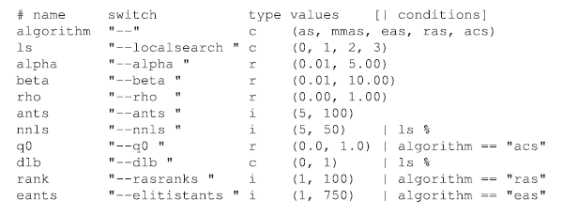

Parameters can be of four types:

• *Real* parameters are numerical parameters that can take any floating-point values within a given range. The range is specified as an interval ‘(< lower bound >, < upper bound >) ’. This interval is closed, that is, the parameter value may eventually be one of the bounds. The possible values are rounded to a number of *decimal places* specified by the option digits. For example, given the default number of digits of 4, the values 0.12345 and 0.12341 are both rounded to 0.1234.

• *Integer* parameters are numerical parameters that can take only integer values within the given range. The range is specified as for real parameters.

• *Categorical* parameters are defined by a set of possible values specified as ‘(< value 1 >, ... , < value n > ) ’. The values are quoted or unquoted character strings. Empty strings and strings containing commas or spaces must be quoted.

• *Ordinal* parameters are defined by an *ordered* set of possible values in the same format as for categorical parameters. They are handled internally as integer parameters, where the integers correspond to the indices of the values (10).